**Scenario (Minion node not ready state)**

Task -  
A Kubernetes worker node, named wk8s-node-0 is in state NotReady.  
Investigate why this is the case, and perform any appropriate steps to bring the node to a Ready state, ensuring that any changes are made permanent.

**step 1.A : validate which node is down**

kubectl get nodes

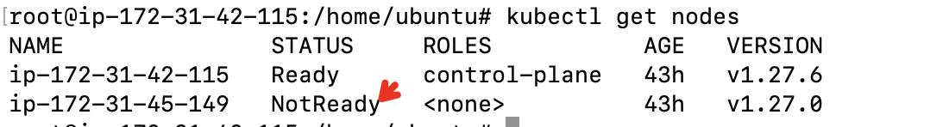

Note : ip-172-31-45-149 node is down

**step 1.B : always describe node to investigate issue**

kubectl describe nodes ip-172-31-45-149

**step 2 : ssh to the node which is down**

ssh ubuntu@ip-172-31-45-149

**step 3 : check kubelet agent status**

service kubelet status

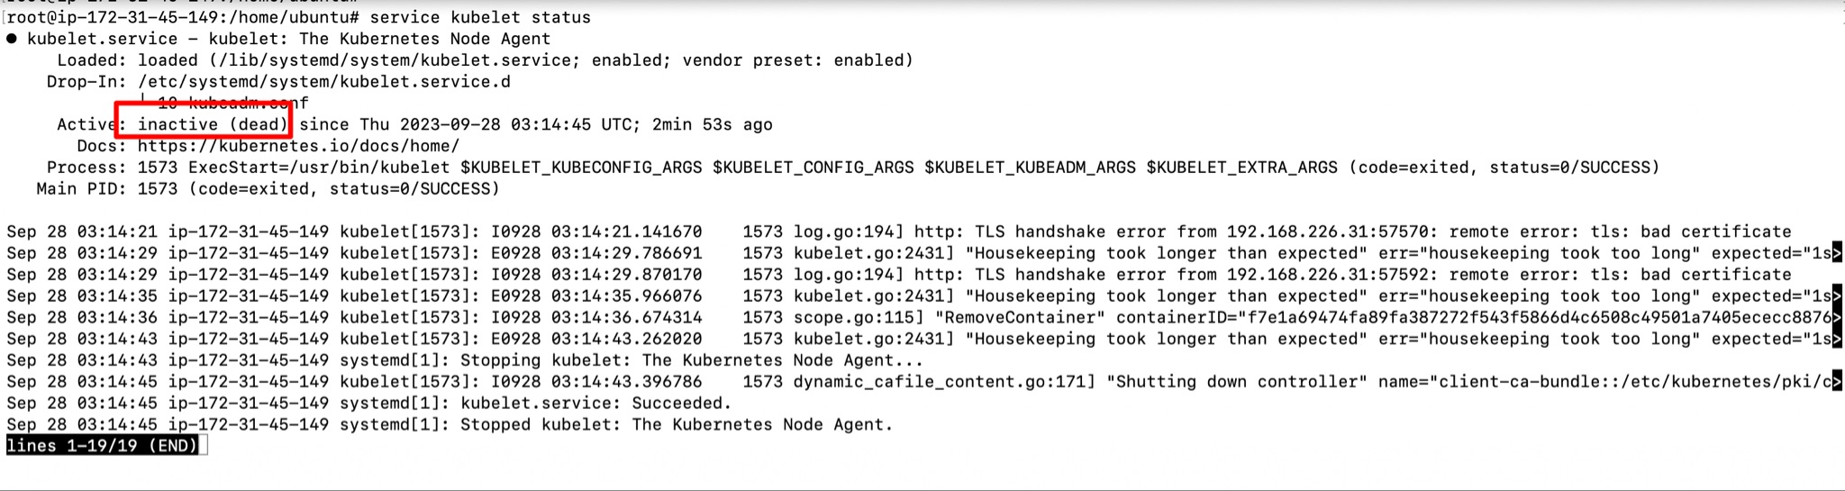

**step 4 : start kubelet agent**

systemctl enable –now kubelet

systemctl start kubelet

**step 5 : check kubelet agent status**

systemctl status kubelet

Note : ensure agent is active

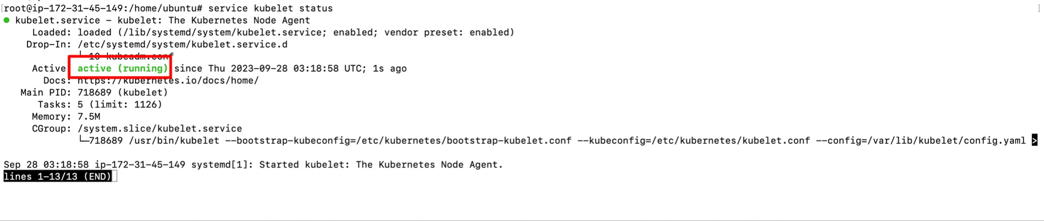

**step 6 : validate which node is up by going to master node**

kubectl get nodes

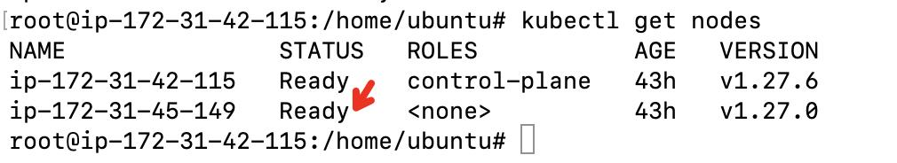

**================ lab Completion =====================**